2021 QAP - Rural/Tribal Designated Areas Methodology
Because communities in rural parts of Minnesota will no longer compete for economic integration priority points, the selection process will now have a new 10 point criterion for rural communities.
Minnesota Housing defines rural communities using tracts outside of the Twin Cities 7-County Metropolitan Area and communities in Greater Minnesota with populations over 50,000. These areas include tracts in, Duluth, Rochester, and St Cloud.
The map below shows areas receiving the rural/tribal designation points in orange. The following pages list the tracts eligible by county.
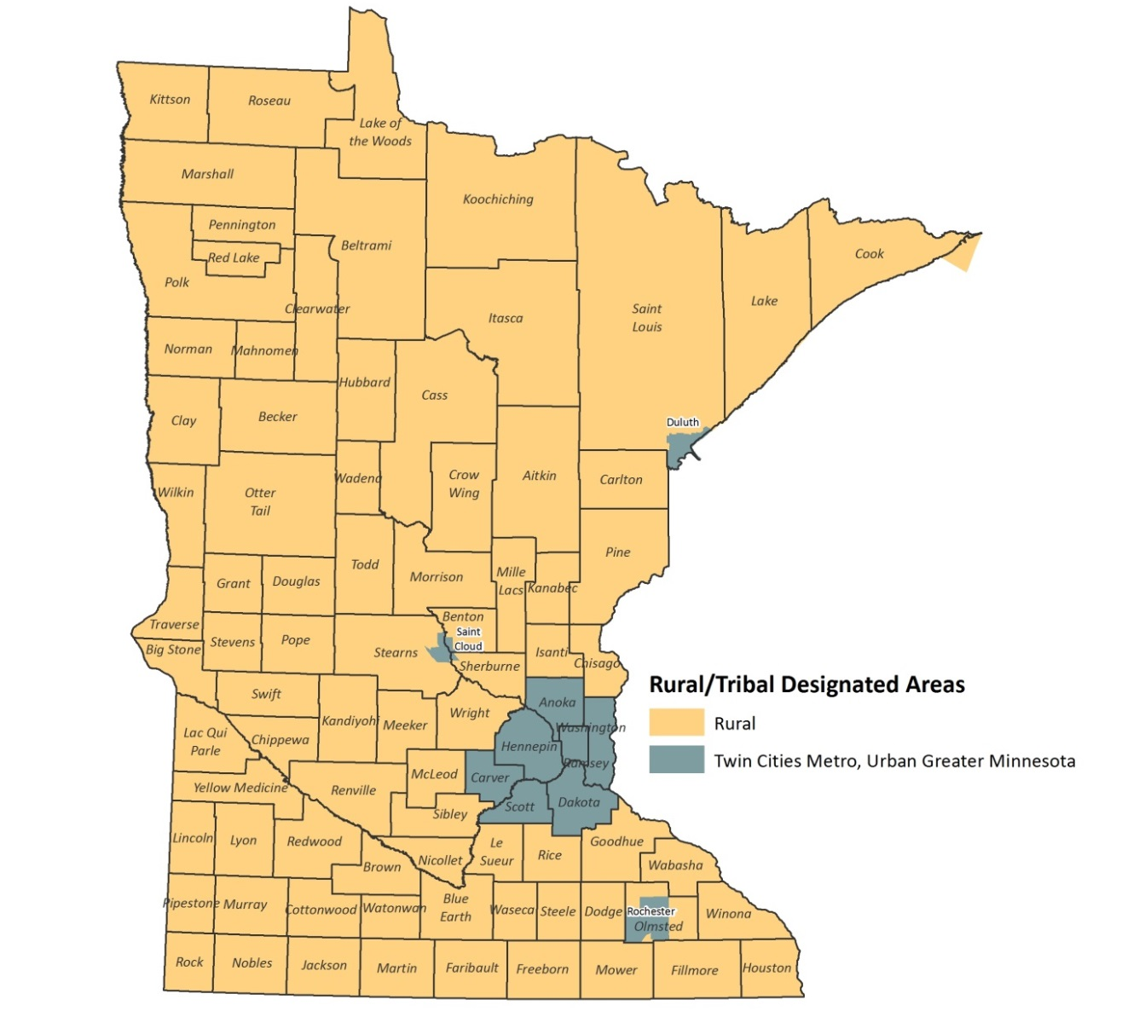

Tracts Eligible for Rural/Tribal Designation Points

Aitkin
7701
7702
7703
7704
7905.01
7905.02
Becker
4501
4502
4503
4504
4505
4506
4507
4508
4509
9400
Beltrami
4501
4502
4503
4504
4505
4506
4507.01
4507.02
9400.01
9400.02
Benton
201
202.02
202.03
202.05
203
Big Stone
9501
9502
9503
Blue Earth
1701
1702
1703
1704
1705
1706
1707
1709
1710
1713
1714
1715
1708
1712.02
1716
1711.01
Brown
9601.01
9601.02
9602
9603
9604
9605
9606
9607
Carlton
701
702
703
704
705
706
9400
Cass
9400.01
9400.02
9601
9602
9603.01
9603.02
9606
9607
9608.01
9608.02
Chippewa
9503
9504
9505
9506
Chisago
1101
1102
1103.01
1103.02
1104.02
1105.01
1105.02
1106
1107
1104.01
Clay
201
202.02
203
204
205
206
301.02
301.07
302.01
302.02
301.06
301.03
301.04
Clearwater
1
2
3
Cook
4801
4802
Cottonwood
2701
2702
2703
2704
Crow Wing
9501
9502.04
9504
9505.01
9505.02
9507
9508
9509
9510
9511
9512
9513.01
9513.02
9514
9516
9517
Dodge
9501
9502
9503
9504
9505
Douglas
4501
4502
4505
4506
4507.01
4507.02
4508
4509
4510
Faribault
4601
4602
4603
4604
4605
4606
Fillmore
9601
9602
9603
9604
9605
9606
Freeborn
1801
1802
1803
1804
1805
1806
1807
1808
1809
1810
Goodhue
801.01
801.02
802
803
804
805
806
807
808
809
Grant
701
702
Houston
201
202
203
205
209
Hubbard
701
702
703
704
705
706
707
Isanti
1301
1302
1303.01
1303.02
1304
1305.01
1305.02
1306
Itasca
4801
4803
4804
4805
4806
4807
4808.01
4808.02
4809
4810
9400
Jackson
4801
4802
4803
4804
Kanabec
4801
4802
4803
4804
Kandiyohi
7709
7801
7802
7803
7804
7805
7806
7807
7808
7810
7811
7812
Kittson
901
902
Koochiching
7901
7902
7903
7905
Lac Qui Parle
1801
1802
1803
Lake
3701
3703
3704
Lake of the Woods
4603
4604
Le Sueur
9501
9502
9503
9504
9505
9506
Lincoln
2010.01
2010.02
Lyon
3601
3602
3603
3604
3605
3606
3607
Mahnomen
9401
9403
Marshall
801
802
803
804
Martin
7901
7902
7903
7904
7905
7906
McLeod
9501
9502
9503
9504
9505
9506
9507
Meeker
5601
5602
5603
5604
5605
5606
Mille Lacs
1704
1705
1706
1707
9701
9702
9703
Morrison
7801
7802
7803
7804
7805
7806
7807
7808
Mower
1
2
3
10
12
13
14
4.1
6
8
9
Murray
9001
9002
9003
Nicollet
4801
4802
4803
4804
4806
4805.01
4805.02
Nobles
1051
1052
1053
1054
1055
1056
Norman
9601
9602
9603
Olmsted
18
19
20
21
Otter Tail
9601.02
9601.03
9603
9604
9605
9606
9607
9608
9609
9610
9611
9612
9613
9614
9615
9616
9617
Pennington
901
902
903
904
905
Pine
9501
9502
9503
9504
9505
9506
9507
9508
Pipestone
4601
4602
4603
4604
4605
Polk
201
202
203
204
205
206
207
208
209
210
Pope
9701
9702
9703
9704
Red Lake
101
102
Redwood
7501
7502
7503
7504
7505
7506
Renville
7901
7902
7903
7904
7905
7906
Rice
701
702
703
704
705.01
705.03
705.04
706.01
706.02
707
708
709.01
709.02
Rock
5701
5702
5703
Roseau
9701
9702
9703
9704
9705
Saint Louis
104
105
106
111
112
113
114
126
127
128
130
131
132
133
134
135
136
138
139
140
141
151
152
153
154
155
121
122
123
124
125
Sherburne
301.01
301.02
302
303
304.02
304.03
304.04
305.02
305.03
305.04
Sibley
1701.98
1702
1703
1704
Stearns
102
104.01
104.02
104.03
105
106
109
110
111
112
113.02
113.04
114
115
Steele
9601
9602
9603
9604
9605
9606
9607
9608
Stevens
4801
4802
4803
Swift
9601
9602
9603
9604
Todd
7901
7902
7903
7904
7905
7906
7907
7908
Traverse
4601
4602
Wabasha
4901
4902
4903
4904
4905
4906
Wadena
4801
4802
4803
Waseca
7901
7902
7903
7904
7905
Watonwan
9501
9502
9503
Wilkin
9501
9502
Winona
6701
6702
6703
6704
6705
6706
6707
6708
6709
6710
Wright
1001
1002.02
1002.03
1002.04
1003
1004
1005
1007.01
1007.02
1007.03
1008.01
1008.02
1009
1010
1011
1012
1013
Yellow Medicine
9701
9702
9703
9704

